Ngrok is a sensational, free open source and cross-platform reverse proxy server for exposing local servers behind NATs and firewalls to the public Internet over secure tunnels.

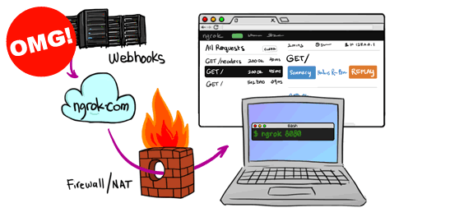

Install Ngrok 2.3.34

We should install ngrok client next to where we have the Jenkins server running



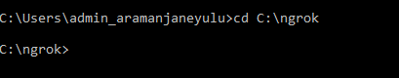

Launch **ngrok** by specifying the http port **8080**



Once you start it, you should see an output similar to the one below in your terminal.

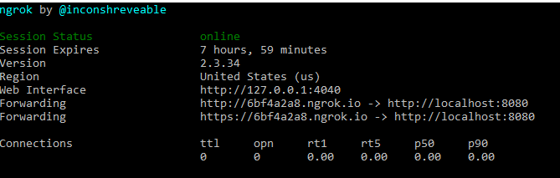

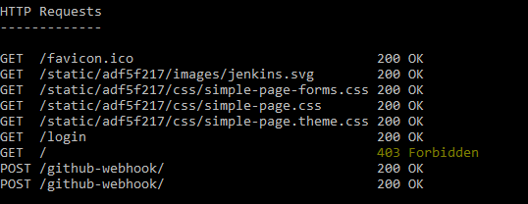

**Ngrok** offers a simple web UI for you to inspect all of the HTTP traffic running over your tunnels in real-time

http://localhost:4040

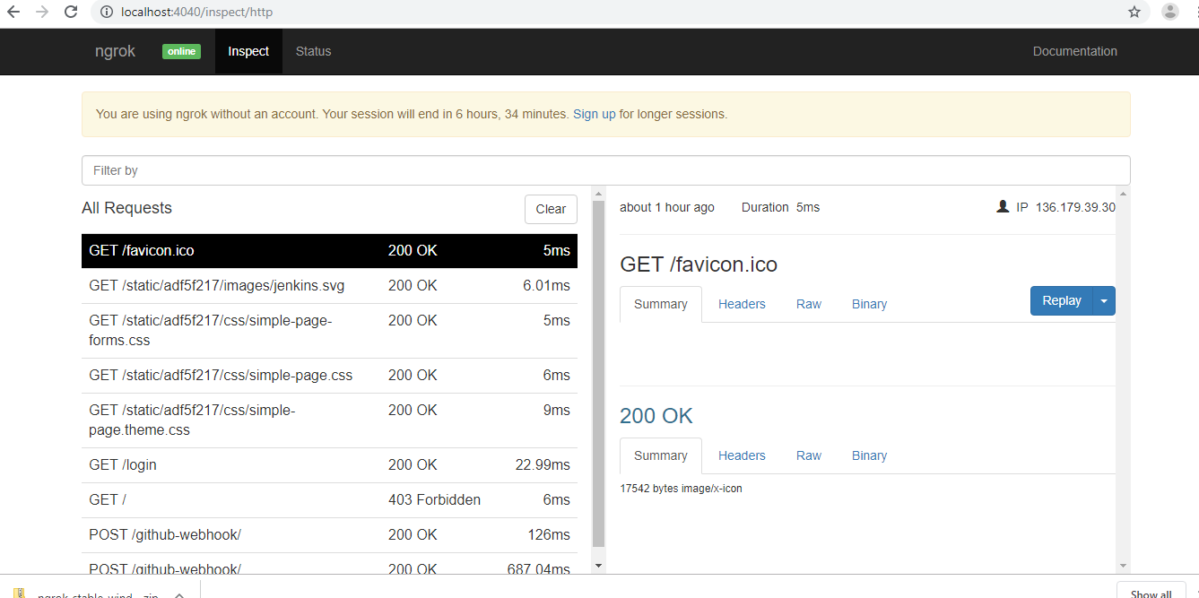

**Ngrok is simply an amazing tool, it is by far the simplest yet powerful secure local tunnel solution you will find out there. You should consider creating a free ngrok account to get more bandwidth, but if you want even more advanced features, try upgrading to a paid account.**

**Github setup**

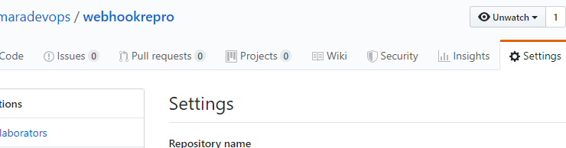

Next, configure the webhook:

* Paste in the “smee” URL you copied from the step above.
* Choose application/json as the content type
* Tell it to send everything (you can pick and choose what events, but I just did that as simpler).
* Press Add Webhook (or update)

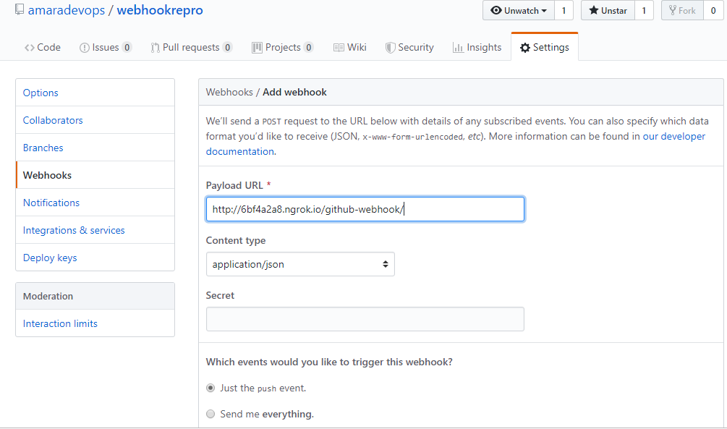

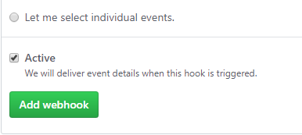

OK - webhooks should be flowing now. You can make a change to your repository, and check that a build starts soon after

**Jenkins job**

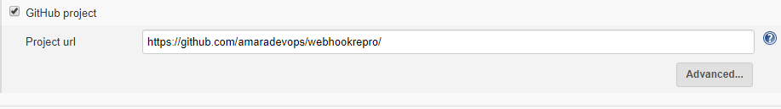

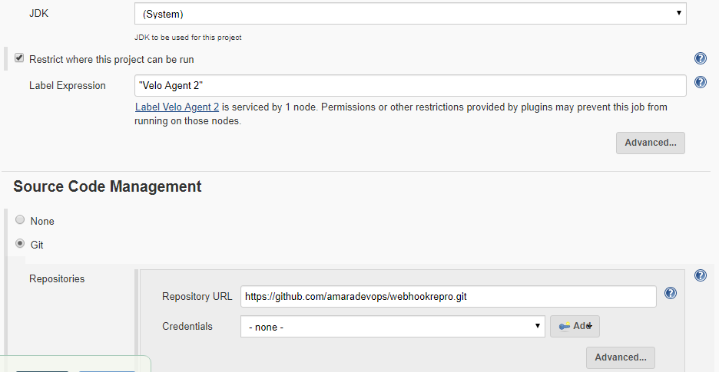



Developer will find a directory where they'd like to store the code. Run this command to clone

git clone <https://github.com/amaradevops/webhookrepro.git>

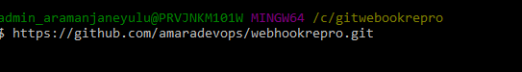

you sign up for an account. Once you've signed up, you need to configure ngrok with the authtoken that appears on your dashboard. This will grant you access to account-only features. ngrok has a simple 'authtoken' command to make this easy. Under the hood, all the authtoken command does is to add (or modify) the authtoken property in your ngrok configuration file.

Install your authtoken

ngrok authtoken <YOUR_AUTHTOKEN>

Disabling Inspection

ngrok records each HTTP request and response over your tunnels for inspection and replay. While this is really useful for development, when you're running ngrok on production services, you may wish to disable it for security and performance. Use the -inspect switch to disable inspection on your tunnel.

Example: An http tunnel with no inspection

ngrok http -inspect=false 80